Nebraska High School Sports Hall of Fame Foundation Fact Sheet

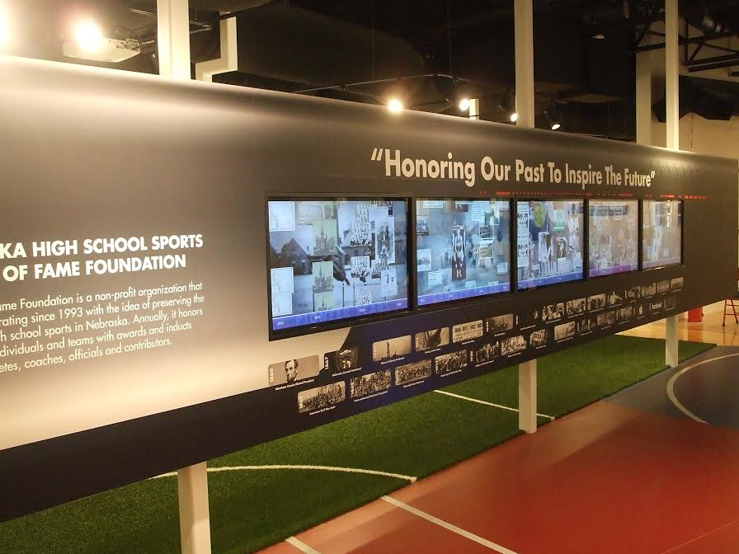

- ADMISSION FREE VENUE
- first class of inductees – 1994
- paper organization until December, 2013 (inductees were recognized on plaques outside of the current exhibit hall)
- Since December, 2013 - exhibit hall contains approx.. 7,500 square feet – located in the NSAA building just north of Haymarket Park
- Space for various sports is marked by the flooring in the exhibit hall (i.e., tennis court in tennis section, volleyball floor in volleyball etc.)
- Partners with NSAA, NSIAAA and NCA
- Each Fall, the NHSSHOFF inducts honorees – individual athletes, coaches, official and contributors. There are outstanding team categories for silver anniversary, golden anniversary and dominant dynasties. The NHSSHOFF also recognizes outstanding families (Fisher Family Award), Inspirational honorees (Gustafson Award) and Great Moments in Sports.
- Over 592 individual honorees inducted
- Among highlights:
  - Hall of Honor – inductees highlighted in front rotunda
  - Interactive Timeline – touchscreen with important events (pictures, videos) since the inception of high school sports in Nebraska
  - Interactive all school kiosk with facts about every current NE high school (and those which have closed) – touch screen record boards in specific sports sections, too!
  - Football, Basketball, volleyball, baseball/softball, wrestling, golf – all with interactive exhibits!!!
  - Wally McNaught Theatre – honoring former LSE coach/AD – this area is for video explaining HOF exhibit hall (also contains wall mural with all NE high school mascots)
  - Various HOF inductees mannequin displays with their high school, professional and Olympic uniforms

- The NHSSHOFF has hosted a Sportsmanship for Life pep rally with middle school students across the state –held in conjunction with UNL athletes and coaches.
- Website has additional information: (visit us at www.nebhalloffame.org)
- phone # 402-476-4767
- email at nhshofff@gmail.com

