Peggy Tilgner always read her campus newspaper front to back.
On Dec. 1, 1967, she got her reward. Beneath reports on the presidential race and the Vietnam War, the communist movement and the University of Nebraska-Lincoln’s parking problem, buried on the back page in the bottom left corner, Tilgner noticed a one-column headline. Her eyes lit up.
Extramural volleyball practice for university women will begin at 4:30 p.m. in the University High School gym for matches with other Nebraska colleges. For further information call Barb Adams at 432-6095.

“I’m going,” Tilgner thought.
Fifty years ago this month, for the first time, the best volleyball players at UNL teamed up for outside competition. They didn’t have financial support. They didn’t have a full-time coach. They didn’t even wear red uniforms. But they started something that endures tonight when the Huskers make their 14th final four appearance.
The wins and losses of 1967-68 are a little fuzzy. Here’s what is clear. The first Nebraska team didn’t just cultivate an elite program, it culminated a forgotten era in the state’s sports history.
+6
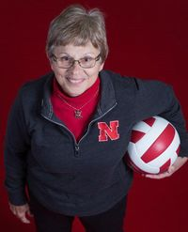
Peggy Tilgner
RYAN SODERLIN/THE WORLD-HERALD
The common perception is that Big Red catalyzed Nebraska’s volleyball culture. Terry Pettit made Nebraska a national name, no doubt. But the seed was planted long before his hire, before Title IX, before the Nebraska Schools Activities Association sponsored a state tournament.
The roots curl back to a time when almost every map dot had a high school, when volleyball was a winter sport and girls played before the boys basketball games, when there were eight players on a side and coaches kept an eye on the clock, when uniforms were satin and the state’s best teams weren’t from Omaha or Lincoln, but Murdock, Verdon and Douglas.
They curl back to the “Campus of a Thousand Oaks” and a century-old brick library. It’s no Devaney Center, but it’s a good place to look for a seed.
* * *
Jackie (Johnson) Kelsay walks into the building of a thousand books at Peru State College and remembers the oddest thing. Echoes.
Today Kelsay, the mother of two former Husker football standouts, is an elementary principal in Auburn. Fifty years ago, she was a spiker from a farm north of Humboldt.
“It’s kind of an eerie feeling,” Kelsay said. “It’s hard to imagine it being a gym anymore. It was just always so noisy.”
Bleachers on the main court were usually full. A second, smaller court crammed against three walls at the gym’s south end. The setting was just big enough to operate Nebraska’s premier high school volleyball event.
“That was the state tournament,” Kelsay said.
It was born in February 1946 as the brainchild of Phyllis Davidson, Peru State director of physical education for women.
Nebraskans had been playing volleyball since early in the 20th century, but the sport took off in high schools after girls basketball was banned in the 1920s — administrators thought basketball was too rough.
Nineteen teams came to Peru State’s first tournament. Admission was free to the public. Final scores looked like this: 64-10, 23-22, 47-19. Steinauer beat Shubert in the championship, 38-22.
In those days, volleyball sets weren’t played to 15 or 25. Scoring resembled a basketball game. Matches were broken into two 15-minutes halves.
Each team had eight players instead of six — four setters, four spikers. They had to stay in their 3-2-3 alignment during points. Only three could touch the ball before sending it back over the net — just like today — but those players could touch it twice consecutively (six total touches per side).
“You could even set it up for yourself to spike,” said Doris (Dettman) Shafer from Verdon.
Everything was open hand; players didn’t bump the ball from their forearms and officials rarely whistled a caught ball. Most refs didn’t know all the rules anyway, they were there to call the basketball games.
Here’s the real head-scratcher. A spiker could score off her teammate’s serve. The 6-foot Sodman sisters at Bratton Union High School were famous for that.
“Oh honey, I liked it so much better,” said Willa Jean (Sodman) Stutheit, who, as a regular attendee of high school games, still doesn’t understand rally scoring. She doesn’t see much similarity in current fashion, either. Uniforms of the 1940s and ’50s were often one-piece jumpers with skirts over the top.
“Weren’t they neat?!” Stutheit said. “We covered up much more of our body than they do now.”
Stutheit, who is quick to correct a reporter who shortens her name — “No, it’s Willa Jean!” — never won it all in Peru. Bratton Union usually lost to rival Verdon. Be careful about bringing that up.
“We shouldn’t have lost,” teammate Vivian Oestmann said. “Our spiker did not have her fingers in the net like the referee said.”
+6
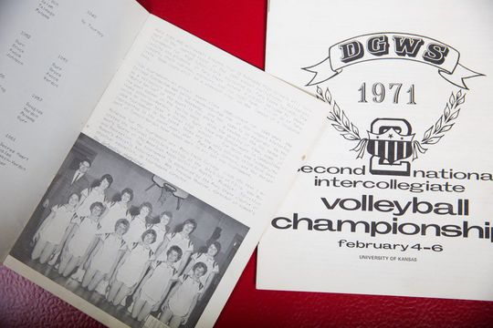
On the right is a program for the 1971 Second National Intercollegiate Volleyball Championships, and on the left is a program from the 1965 girls high school volleyball tournament at Peru State College with champions Murdock pictured.
RYAN SODERLIN/THE WORLD-HERALD
* * *
By the late-1950s, 178 Nebraska schools were playing volleyball and news outlets were calling the end-of-season Peru State tournament “the world series.” Peru called off school so kids could attend.
“It was a classic Hoosiers tournament,” said Dwight Wininger, who grew up in Peru. “One class for everybody.”
The bracket got as big as 43 teams, including several from western Nebraska. In the days before Interstate 80, Dix High School came from 475 miles away only to lose in the second round. Mason City, the best team from the Sand Hills, was known for black-dyed uniforms — its coach thought they would intimidate opponents. Mason City didn’t place in Peru.
Every year produced a huge bracket and new stories. A team got locked in a dressing room. Another team — bitter from elimination — jumped in the basement swimming pool in their team uniforms.
Perhaps the most memorable tournament came in March 1960 when a blizzard swept through Peru. Commence “Operation Mattress.” More than 200 players bunked in girls’ dorms and houses around campus. The next morning, Dawson-Verdon won the championship.
“I think we played five games in two days,” Shafer said. “I was so sore it felt like the first day of practice.”
The 1960s ushered in a new dynasty: Murdock High School, which famously practiced with basketballs. “They were just strong as oxes,” said Waverly’s Shirley (Schlaphoff) Trout. “Oh my gosh.”
Their star player was Pam Rikli. She was 5-foot-5 ½, but she bruised forearms (and foreheads) with her violent spikes. Murdock won the Peru tournament in 1964, ’66, ’67 and ’70 — no school won more championships.
+6
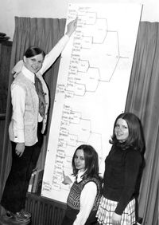
A bracket from the 1971 state tournament.
THE WORLD-HERALD
Rikli’s favorite memory of Peru? The college cafeteria. “That was really special. A lot of us never got to go out and eat.”
Over the years, other big high school tournaments started. Beatrice. Chadron. Hastings. Wayne. Rules slowly evolved to mirror those you see today. The sport moved to the fall, partly because boys weren’t using the gyms — teams of the 1950s and ’60s often practiced before school or on weekends.
But one major change didn’t come until the early 1970s: the participation of Omaha teams.
Of 381 NSAA schools in 1970, 245 were playing volleyball — only Texas, New York and Ohio had more. But here’s the fascinating part: Participants included 135 of 150 Class D schools, 79 of 128 Class C schools, 20 of 64 Class B schools and only eight of 32 Class A schools.
Why were big schools so late to the party? Interviews with more than 20 sources don’t reveal many firm answers. The explanation probably comes back to stereotypes.
Take this 1972 quote from Gloria Mitchell, who started coaching volleyball at Class A Kearney High in the late-’60s.
“When we started, the girls were kind of tomboyish, the kind who don’t date a lot,” she said. “Now they’re the very popular kids — cheerleaders, real sharp-looking girls.”
In 1971, the Omaha Public Schools still didn’t have volleyball. The Greater Omaha Metropolitan League formed with eight Catholic schools, Papillion, Ralston and Millard. Marian and Mercy split the title. Both traveled to Peru to test their skills against the farm girls.
In the first round, Arlington beat Mercy, and Marian got rolled by Elk Creek, 15-10, 15-5. Imagine a town of 151 people beating Omaha’s best.
Who won it all? Douglas High School. Like most Peru State College champions of the event’s heyday, it doesn’t exist anymore. Neither does the tournament. In 1980, it moved across the street to a new activities center, where it stayed until 2006, when a hole in the roof knocked the tournament off the calendar. It never returned.
The event was never quite the same after 1972, though, when the NSAA finally sponsored the first official state tournament. Peru wanted to host, but the honor went to Scottsbluff, almost 500 miles away.
Marian, just one year after losing to Elk Creek, capped an undefeated season by beating Beatrice for the first Class A championship. Tilgner watched courtside.
“The first couple state tournaments,” she said, “frankly the C and D teams could’ve wiped the A teams right off the mat.”
+6
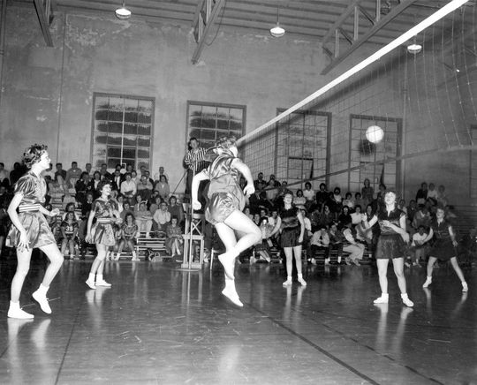
Dawson-Verdon scores against Tobias during a match at the 1962 Peru State tournament for high school teams.
THE WORLD-HERALD
* * *
The girls came from towns like Plymouth and Bennet, Paxton and Daykin, Filley and Waverly.
“I was never so glad in my life to find out that Pam Rikli from Murdock was on my side of the net,” Peggy Tilgner said.
Most members of the first Nebraska volleyball team were used to packed high school gyms, but the fanfare didn’t translate to Lincoln, where even the best female athletes encountered resistance.
Carol Frost, the Olympian discus thrower, was banished to the fairgrounds to practice — she stored her equipment in barns.
Every winter, the volleyball team had a new coach, usually a graduate student fulfilling a teaching credit. Players essentially ran their own practices, replicating their high school drills.
The college provided white uniform tops and blue polyester shorts, but only to P.E. majors — other players purchased their own from a sporting goods store downtown. Football trainer George Sullivan sneaked them athletic tape. They set up chairs before matches.
+6
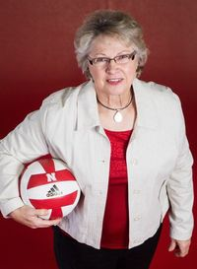
Pam (Rikli) Miller
RYAN SODERLIN/THE WORLD-HERALD
“It was just wherever you could find a court,” Pam (Rikli) Miller said. “We didn’t play at the Coliseum. We wouldn’t have had anybody there.”
But they got better and better and, on Feb. 3, 1971, Nebraska volleyball packed a couple of school vans and headed to Lawrence, Kansas, to compete in its first national tournament.
It faced teams like Texas Woman’s University and Long Beach State, with real coaches and real strategies. Nebraska went 3-3 in pool play, failing to advance to the quarterfinals. Not that many people back home noticed.
Title IX, the federal gender equity legislation, came in 1972, prompting the first season of university-sponsored Husker volleyball in 1975.
Pettit arrived two years later and began building his powerhouse. His first teams were stocked with native daughters, from places like Columbus, Fremont, Trumbull, Sterling, Blair and Randolph. (And don’t forget a deft setter from Beatrice named Lori Melcher, whose daughter is current Husker setter Kelly Hunter).
Nebraska volleyball has attracted crowds ever since.
Tuesday night en route to Kansas City, the Husker bus rolled down Interstate 29 within a few miles of the Campus of a Thousand Oaks and the creaky library floor.
The next morning, at The World-Herald’s request, five pioneers of Nebraska volleyball reunite at the Devaney Center for a photo shoot that doubles as a reunion. When Pam Miller walks in, her old teammates cheer a face they haven’t seen in decades.
“You guys haven’t changed a bit,” Miller said. She goes around the circle, trying to remember who’s who: “Don’t tell me ... Peggy!”
Over the next two hours, they laugh about their uniforms, their changing figures, their cow-milking days and old high school venues.
Some courts, Miller says, weren’t long enough to be regulation, so there was a line on the back wall. Above the line was out. Below the line was in. Only Karen (Ostrander) Stoner was crazy enough to dive for a ball.
“She believed that she could move the wall,” Trout says.
Every laugh echoes through the empty arena. Imagine playing here in front of 8,000 screaming fans, Jan (Cheney) Svoboda says. Maybe, Shirley Trout says, she would’ve told her future husband to hold off on that engagement ring that prompted her departure after two seasons.
“I was woefully in love.”
High above the floor hang 51 banners commemorating 42 seasons of Nebraska volleyball. Nothing from 1967. The original team has “nothing but memorabilia and memories,” Svoboda said.
They have one more thing: a spiritual connection to the women on the walls, All-Americans like Karen Dahlgren, Jordan Larson and Hunter.
“We really do believe that we had some small part in helping get quality volleyball established,” Trout said. “There was absolutely no glory in it, but I think we raised the bar.”
Before they go out to eat together, they request one more photo outside the Husker locker room. Next to the white wall with red letters: I PLAY FOR NEBRASKA
“We need to let people know,” Tilgner said.

