HEY, IT WORKED IN FOOTBALL…LETS TRY BASEBALL
Thanks to Kevin Warneke of the Flatwater Free Press

Stephen Epler is recognized as the father of six-man football. The teacher from Chester, Nebraska came up with a novel twist to the 11-man game to allow for small schools with limited enrollment to continue to play football. Sharing his concerns with the school superintendent Epler devised a game that for the most part remains very similar to what he envisioned. Debuting on September 26, 1934, with a contest held at Hebron College, athletes from Chester and Hardy compete against a team made up of athletes from Belvidere and Alexandria. The game ended in a 19-19 tie. By today’s standards it was a low scoring affair.
The 6-man game took off in part due to the Depression and the waning number of boys due to financial hardships and the impending world war. Once introduced the game exploded across the country and even into Canada and other countries. It was because of this success that Epler toyed with another popular sport. In the late 1930’s Epler proposed the idea of baseball using 6 players. It was his vision that the game would be fast paced and give players more opportunity to bat and due to mandatory rotation, play different positions. Modifying the at bat and scoring the game was at best a “flash in the pan”. While numerous schools experimented with the game it revealed a flaw that was hard to overcome. The players in the outfield not only patrolled the outfield but due to the infielders having to move in they were responsible for the area behind the infielders. Too much ground to cover. It was one of those “nice try”, but the game quickly faded away and was soon lost. Even Epler stopped promotion and as time went on failed to mention the experiment. Epler is remembered for making the game of football more available for small schools with limited enrollment. That success alone is reason to thank him for his contribution to high school sports
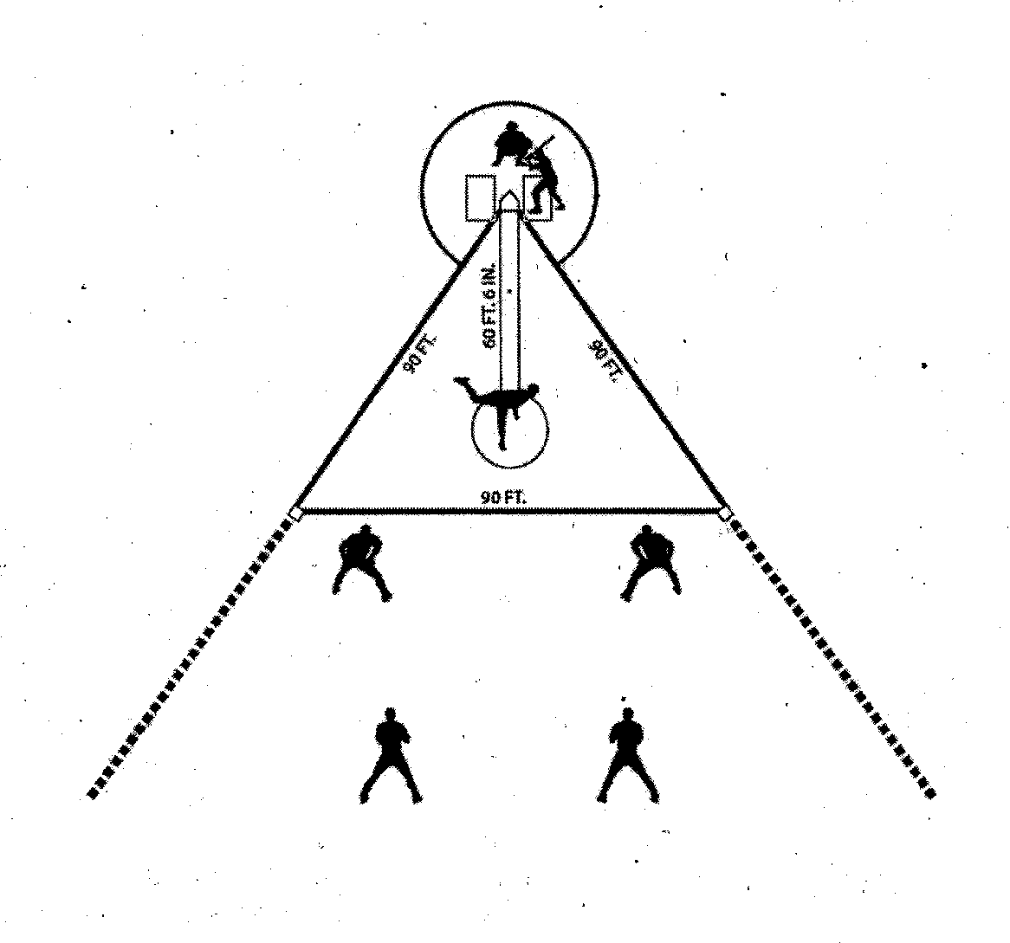
Four outs to a side, two strikes equaling an out, three balls a walk
A foul ball was a half-strike Players rotated after each batter.
The game was comprised of 6 innings

