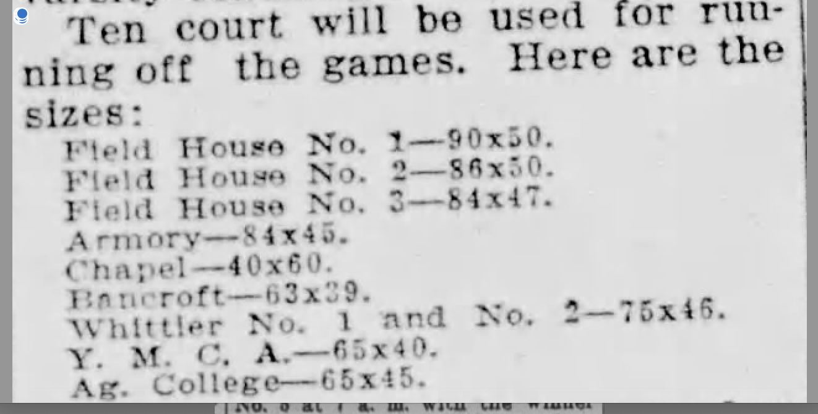
THE THREE ARTICLES ARE TAKING FROM THE NHSAA BULLETIN PRIOR TO THE 1926 AND 1927 STATE BOYS BASKETBALL TOURNAMENT. THE ABOVE ARTICLE OUTLINES THE FLOORS TO BE USED IN THE MASSIVE TOURNAMENT OF 339 SCHOOLS. OF NOTE IS THE LAST ENTRY CITING THE DIMENSIONS FOR THE FLOOR AT THE AG CAMPUS. WHERE THIS FLOOR WAS LOCATED IS UNCERTAIN AS THE NEW GYM HAD NOT YET BEEN COMPLETED. SEE THE NEXT ARTICLE. THE ABOVE ARTICLE NOTES GAMES BEING PLAYED IN THE ARMORY AND CHAPEL. THOSE FLOORS WERE LOCATED IN THE NOW DEFUNCT GRANT BUILDING LOCATED ON THE UNL CAMPUS. NAMED FOR THE FORMER UNION GENERAL AND LATER PRESIDENT IT WAS USED BY THE CAMPUS STUDENT GROUP THAT BECOMES THE PERSHING RIFLES.
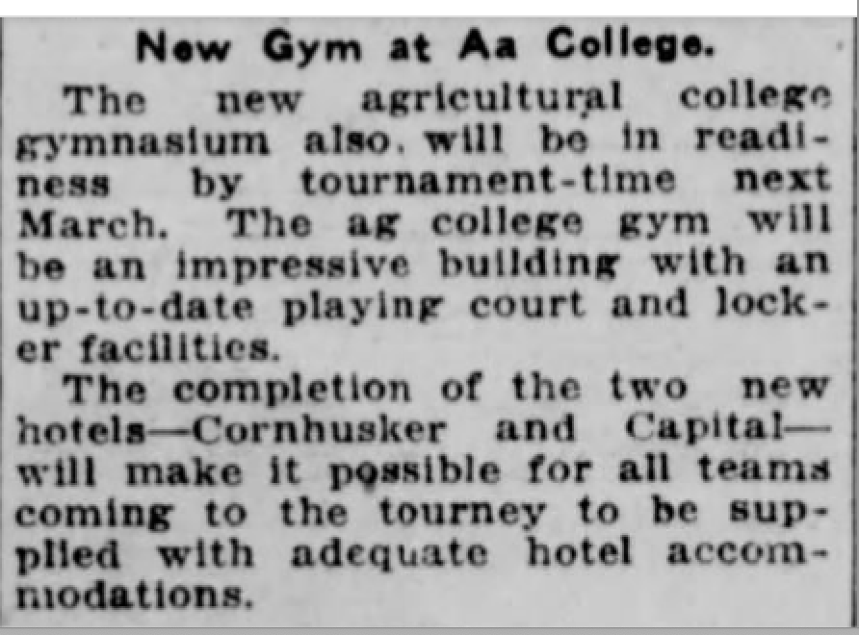
THE ADJOINING ARTICLE APPEARED AFTER THE 1926 TOURNEY AND NOTES THE CONSTRUCTION OF THE NEW GYM ON EAST CAMPUS.
THIS BUILDING WAS RECENTLY RENOVATED AND CURRENTLY IS THE AG CAMPUS REC CENTER
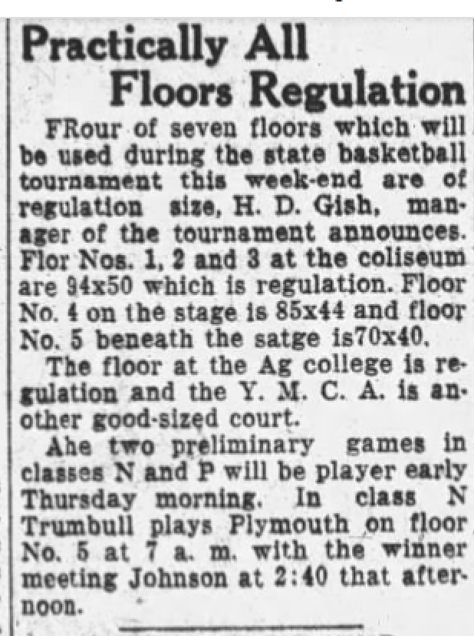
THE 1927 TOURNAMENT SAW THE USE OF SIX FLOORS FOR THE PARTICIPATING 16 CLASSES.
THE UNL COLISEUM WAS NOW COMPLETE ALLOWING FOR THE USE OF 5 FLOORS. THIS INDICATES THAT IN THE EARLY GAMES THEY DID PLAY CROSS COURT ON THE COMPETITON FLOOR.
THE FLOOR IN THE BASEMENT WOULD EVENTUALLY BE CONVERTED INTO A POOL AND SAW THE FIRST STATE SWIM MEET HELD THERE IN 1932.

